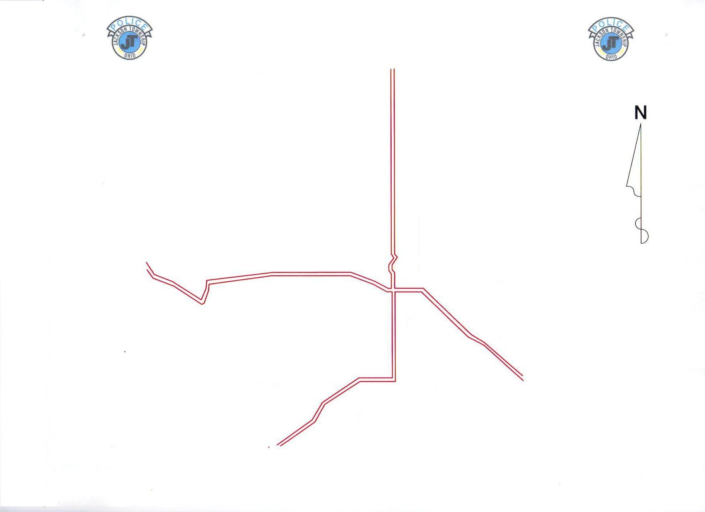
JACKSON TOWNSHIP POLICE ZONES
3
4
2
1
4 Business
Sergeant Josh Escola
Officer Rob Rowland
Officer Tommy Minarcheck
Officer Will Grimmett
Officer Aundreea Genovese
Officer Jena Dugan
Sergeant Jake Hall
Officer Tonya Leon
Officer Anthony Richardson
Officer Colt Weber
Officer Haley Hiller
Officer Jason Gerber

Sergeant Steve Johnson Officer Brian Ayers
Officer Lucas Shanklin
Officer Evan Betz
Officer Gary Frascone
Officer Kyle Trsinar
Officer Andrew Mossor

Sergeant Nick Hesse
Officer Eddie Watson
Officer Andy Speight
Officer David Roberts
Officer Kayla Ivey
Officer Edward Tournoux
Officer Ryan Scott

Sergeant Jamin Sprowl
Officer Matt Rouse
Officer Zach VanVoorhis
Officer Scott Webb
Officer Andrew Smith
Officer Alexis Kakoules

Sergeant Dustin McDannold
Officer Ryan Risher
Officer Kelly Vigars
Officer Dustin Kempf
Officer Matt Demyan
Officer Daniel Griffiths
Officer Parker Crim

L
A
K
E

O’
S
P
R
I
N
G
S
FULTON DRIVE

FULTON DRIVE

B
R
U
N
N
E
R
D
A
L
E

LAST UPDATED 12-18-24

